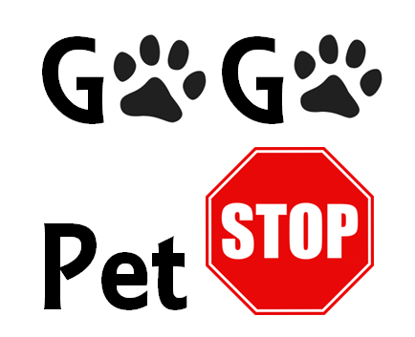 G G

Pet

C:\Users\Linda\AppData\Local\Microsoft\Windows\Temporary Internet Files\Content.IE5\2HXXK961\MC900019209[1].wmfCALL US AT: 1-(800)-GO-PETS

CHECK OUT OUR WEBSITE:

GOGOPETSTOP.WEEBLY.COM

EMAIL:

[GOGOPETS@GMAIL.COM](mailto:GOGOPETS@GMAIL.COM)

Don’t worry about where your buddies stay!

Book with Go Go Pet Stop today!